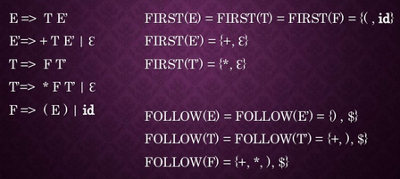

|  |  |
| --- | --- |
| S->CC  C->cC|d | FIRST(S) = {c, d} ; FIRST (C )= {c,d}  FOLLOW(S) = {$} ; FOLLOW(C ) = {c,d} |

